Croodaceous Creatures

Available on Digital HD September 15 and Blu-ray & DVD October 1

Throughout their adventure, the Croods encounter tons of unique croodaceous creatures. The beauty of these peculiar animals that they had never seen before amazed audiences across the world. Continue reading below to learn all of the background information on these wild animals, and get to know the Croods’ co-stars on a deeper level.

Join the Croods on the journey of a lifetime in the epic comedy-adventure that "has the magical wonder of How To Train Your Dragon" - Jake Hamilton (Fox-TV). When their cave is destroyed, the Croods set out to explore a spectacular landscape filled with fantastic creatures, strange surprises…and a whole new world of adventure!

Mousephant

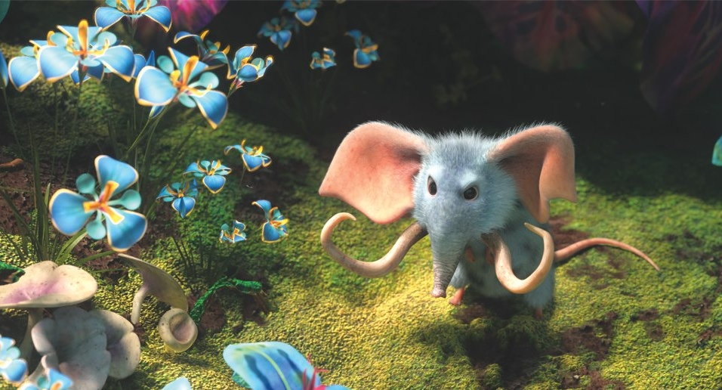

The tiny blue mousephant is only 4 to 5 inches in length and is often preyed upon by other larger croodaceous creatures. For this reason, the mousephant uses it’s large ears to hear long distances and tiny trunk to make loud, intimidating trumpet noises. This furry blue animal snacks on a wide array of plants and, as seen in the film, often travels in packs.

Crocopup

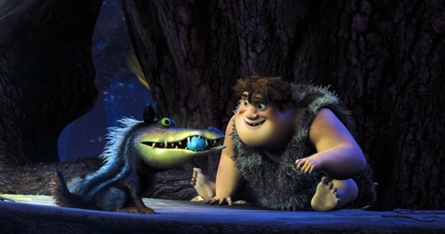

Thunk’s favorite animal pal, the crocopup, is a playful reptomammal. Crocopups use their large eyes, sharp teeth, and strong jaws to hunt for food. Although the crocopup is about 200 to 300 pounds with short powerful legs and a strong bite, they still have to be careful of their main predator, the bear owl.

Macawnivore

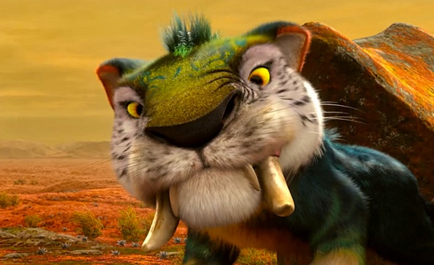

If you’re a cat person like Grug, the macawnivore would be the perfect pet for you! This 15-foot creature is a speedy hunter that has no known predators from the whole croodaceous era. The macawnivore’s colorful feather body and large saber teeth make it a beautiful sight to see in nature.

Punch Monkey

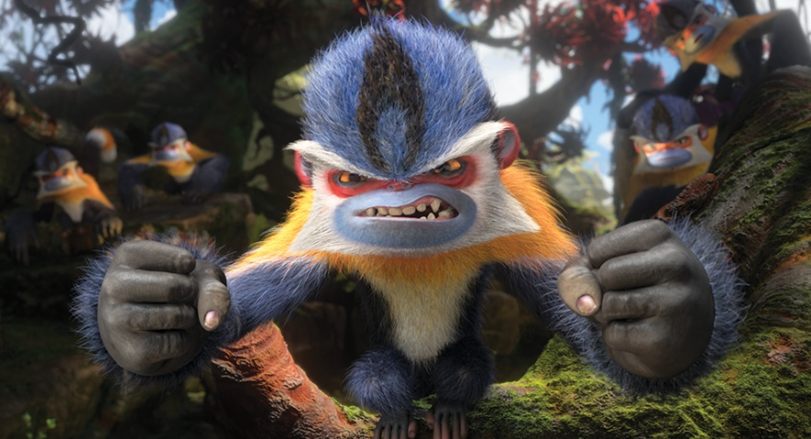

The punch monkey’s large fists are used for their favorite activity: fighting! Punch Monkeys use their tails as a third hand, and are willing to fight anyone who intrudes on their territory. But, if you offer them any sweet fruit such as a banana, you will be safe from their powerful punch.

Piranhakeet

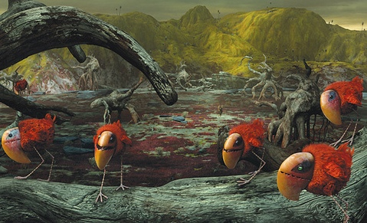

The piranhakeet is the most frightening creature in the croodaceous environment. Each night, the piranhakeets fly from their underground hiding place in a giant red swarm to find their next source of food. These vicious birds leave nothing behind but the skeleton. However, their fear of light makes them easy to defeat.

